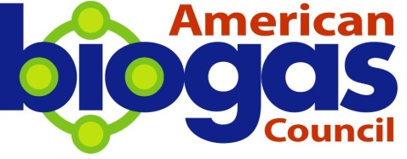

Operators Working Group
Meeting Notes—March 2nd, 2016

Call-in: 877-424-1233
Join us: www.uberconference.com/ambiogascouncil

Chairs
- Paul Greene, Natural Systems Utilities LLC
- Mark Stoermann, Newtrient LLC

Attendees
- Bernie Sheff, ES Engineering Services, LLC
- John Haeckel, Clean Fuel Partners
- Daniel Zitomer, Marquette University
- Darn cash, Harvest Power
- Christopher, London fisher

ABC Staff
- Patrick Serfass
- Caroline Peat
- Ayyaantu Abduselam

Action Items Highlighted

Goals of Group – Mission Statement
The Operators WG is intended to be a safe setting to discuss operational best practices, training and operational issues at biogas plants in a way that is helpful to all and spans multiple process technologies.

Agenda
- Welcome and Antitrust (Caroline, 2:05)
- Presentation
  - John Haeckel, President of Clean Fuel Partners, will provide an “Owners” view point on what he needs and expect from operators.
- Open Discussion
  - Talked to Daniel Zitomer, new member, about membership.
- Start Planning for Spring & Summer (Mark Stoermann, Newtrient LLC)
  - Will discuss on the next call.
- Next meeting: April 13th at 1 PM ET

